* **دستورات Update و Insert**

INSERT INTO _user (MobileNumber, first_name, last_name, _password,balance, registration_date)  
VALUES  
('09122377137',N'علی', N'غلامی', 'ali20',0, '2021-05-23'), --1  
('09107725412' ,N'زهره', N'رسولی', 'r326',0, '2020-02-09'), --2  
('09161734675',N'الهام', N'نیایشی', 'en2023',0, '2021-11-17'), --3  
('09101736070',N'رضا', N'ملکی', 'rm2455',0, '2021-10-01'), --4  
('09013456901',N'مرتضی', N'مولایی','mm4590', 0, '2021-06-21'), --5  
('09197724709',N'سعید', N'حجازی', '#sh34',50000000, '2020-10-18'), --6  
('0017147193659',N'جان', N'ویک','kill2022',1000000000,'2020-08-11'), --7  
('09078724100',N'آرمان', N'فدایی', 'fa30',15000000, '2021-11-15'), --8  
('09128006468',N'محمد', N'سجادی', 'MSJ90',7500000, '2021-03-05'), --9  
('09173278132',N'علی', N'محمدی', 'am_456',320000000, '2021-09-05'); --10  
  
INSERT INTO _user (MobileNumber, first_name, last_name, _password,balance, registration_date)  
VALUES  
('09122399137',N'سارا', N'بدیعی', 's@bsb',0, '2020-01-23'), --11  
('09122377904',N'ایلیا', N'احمدپور', 'ilix100',0, '2021-12-20'); --12  
  
UPDATE _user  
SET email = 'gholami2022@gmail.com'  
WHERE id = 1  
  
UPDATE _user  
SET email = 'saeed20@gmail.com'  
WHERE id = 6  
  
UPDATE _user  
SET email = 'w_john@gmail.com'  
WHERE id = 7

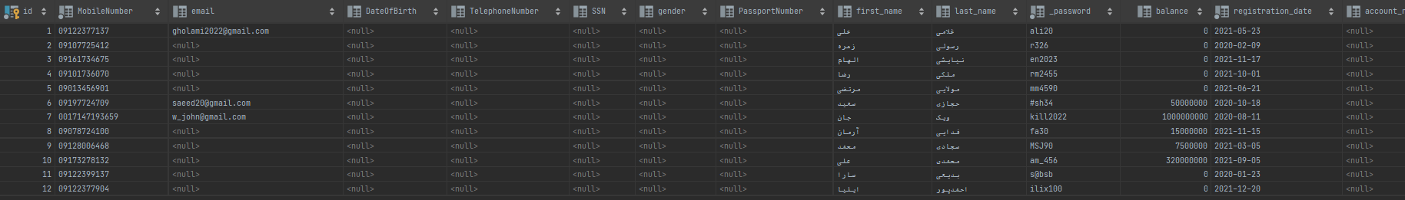

INSERT INTO Transactions (amount, _type, _date, userid)  
VALUES  
(50000000, 'increment', '1400/08/12', 6),  
(1000000000, 'increment', '1400/07/07',7),  
(15000000, 'increment', '1400/10/05', 8),  
(7500000, 'increment', '1398/12/27', 9),  
(320000000, 'increment', '1399/01/20', 10);

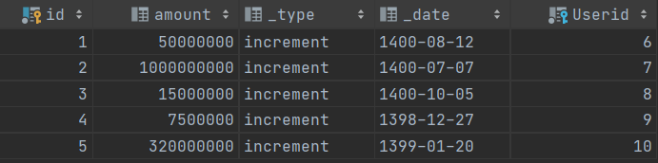

INSERT INTO country (name)  
VALUES  
(N'ایران'); --1

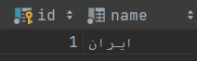

INSERT INTO City (name, countryid)  
VALUES  
(N'تهران', 1), --1  
(N'مشهد', 1); --2

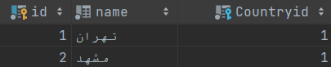

INSERT INTO Company (name)  
VALUES  
(N'ایران پیما');



INSERT INTO Transport (time, _date, duration, capacity, origin_city_id, destination_city_id, Companyid)  
VALUES  
('13:30', '1400/09/23', '12:00', 22, 1, 2, 1), --1  
('15:30', '1400/09/24', '13:00', 22, 1, 2, 1); --2



INSERT INTO Bus_Terminal (name, cityid)  
VALUES  
(N'غرب', 1),  
(N'امام رضا', 2),  
(N'جنوب', 1);

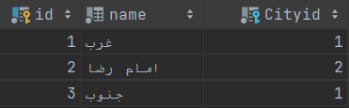

INSERT INTO Bus (transportnumber,bus_origin_terminalid, bus_destination_terminalid)  
VALUES  
(1, 1, 2),  
(2, 2, 1);



BEGIN  
 DECLARE @num int  
 DECLARE @count int  
 SET @num = 1  
 SET @count = 1  
WHILE @count <= 22  
 BEGIN  
 INSERT INTO Ticket (seat_number,ticket_number ,_status, Transportnumber, cost, _type)  
 VALUES (@num , @num, 1, 1,'1910000', 'VIP')  
 SET @count = @count + 1  
 SET @num = @num + 1  
 END  
END;

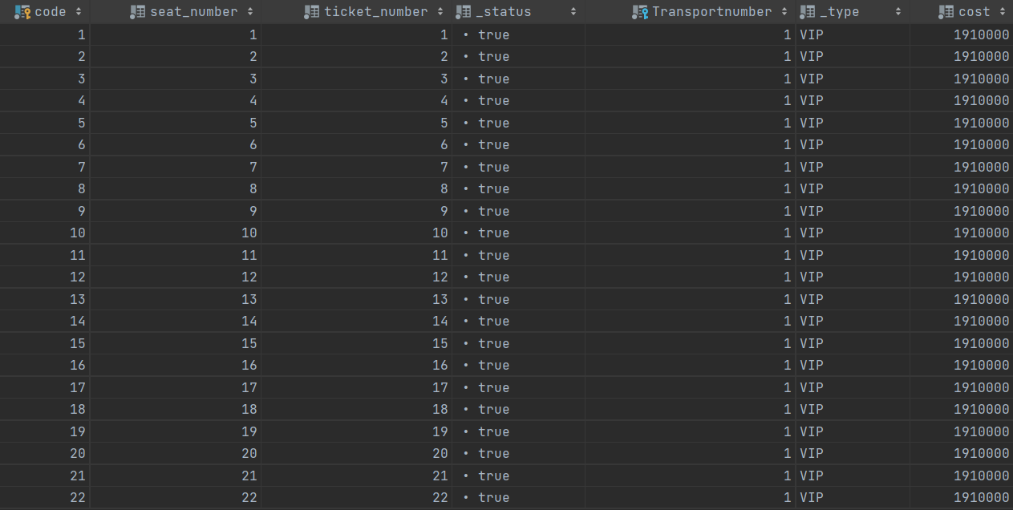

BEGIN  
 DECLARE @num int  
 DECLARE @count int  
 SET @num = 1  
 SET @count = 1  
 WHILE @count <= 22  
 BEGIN  
 INSERT INTO Ticket (seat_number,ticket_number ,_status, Transportnumber, cost, _type)  
 VALUES (@num , @num, 1, 2,'1910000', 'VIP')  
 SET @count = @count + 1  
 SET @num = @num + 1  
 END  
END;

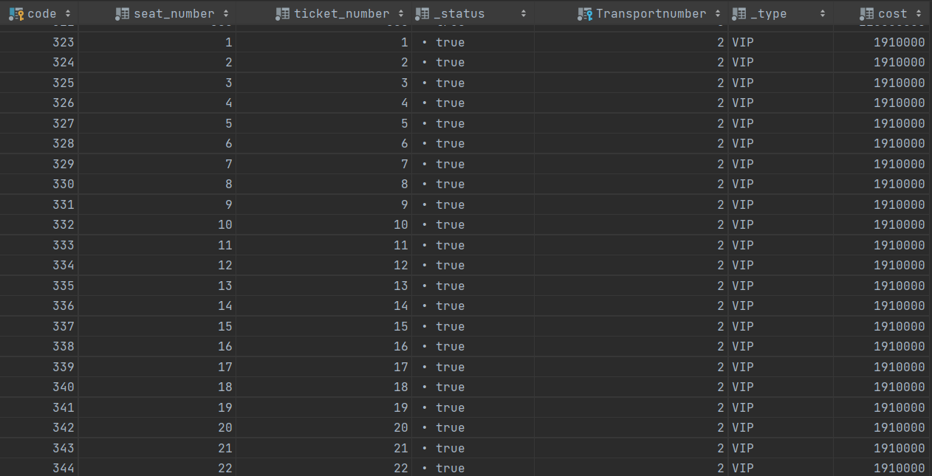

INSERT INTO country (name)  
VALUES  
(N'آمریکا'), --2  
(N'قطر'); --3

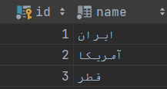

INSERT INTO city (name, countryid)  
VALUES  
(N'لس آنجلس', 2), --3  
(N'دوحه', 3), --4  
(N'سانفرانسیسکو', 2); --5

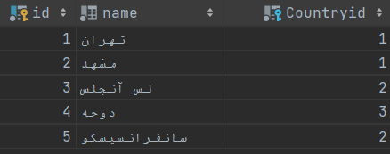

INSERT INTO transport (time, _date, duration, capacity, origin_city_id, destination_city_id, Companyid)  
VALUES  
('4:45', '1400/09/20', '22:30', 300, 3, 1, 4); --3



BEGIN  
 DECLARE @num int  
 DECLARE @count int  
 SET @num = 1  
 SET @count = 1  
 WHILE @count <= 300  
 BEGIN  
 INSERT INTO Ticket (seat_number,ticket_number ,_status, Transportnumber, cost, _type)  
 VALUES (@num , @num, 1, 3, 220000000, '')  
 SET @count = @count + 1  
 SET @num = @num + 1  
 END  
END;

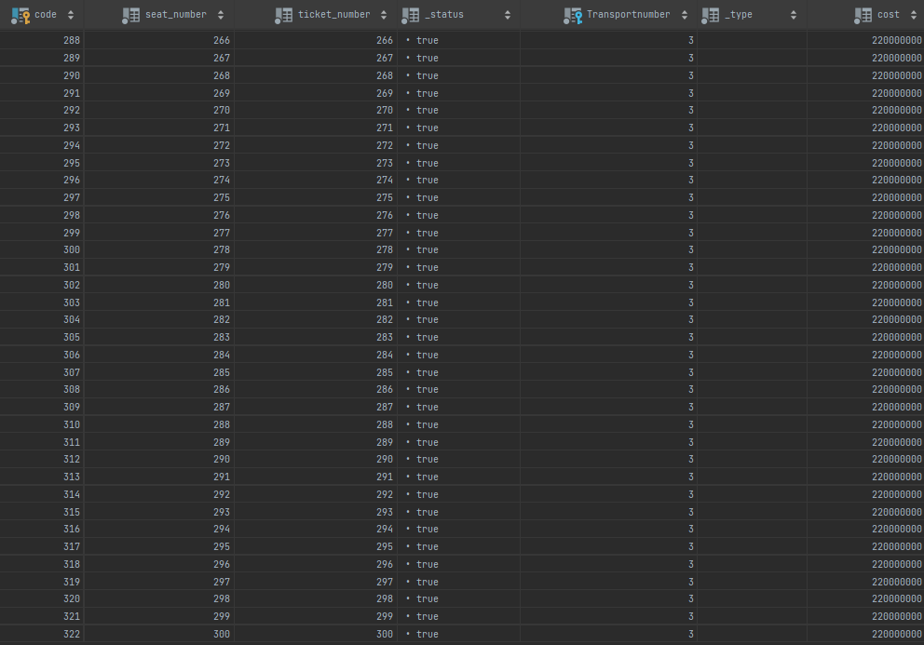

INSERT INTO airport (name, cityid)  
VALUES  
('Imam Khomeini(IKA)', 1), --1  
('Doha(DOH)', 4), --2  
('San Francisco Intl.SFO)', 5), --3  
('Los Angeles international Airport(LAX)', 3); --4

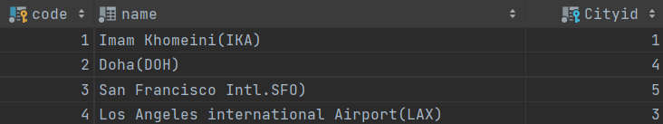

INSERT INTO flight (transportnumber, class, amount_of_allowed_baggage, Airportcode_origin, Airportcode_destination)  
VALUES  
(3, N'اکونومی', 23, 3, 1);



INSERT INTO Overseas (FlightTransportnumber)  
VALUES (3)



INSERT INTO flight_legs (duration, OverseasFlightTransportnumber, Airportcode)  
VALUES  
('1:30', 3, 2),  
('6:30', 3, 3);



INSERT INTO transport_reservation (_date, number_of_adult, number_of_children, userid, Ticketcode)  
VALUES  
('1400/08/30', 1, 0, 7, 3);



UPDATE _user  
SET balance = balance - (SELECT cost FROM ticket WHERE Transportnumber = 3 and ticket_number = 1)  
WHERE id = 7;

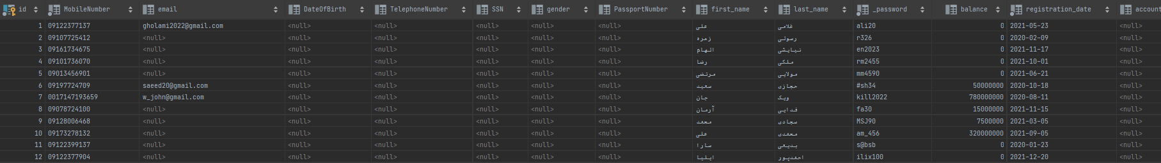

INSERT INTO transactions (amount, _type, _date, userid)  
VALUES  
((SELECT cost FROM ticket WHERE Transportnumber = 3 and ticket_number = 1),'overseas_flight_reservation', '1400/08/30', 7);

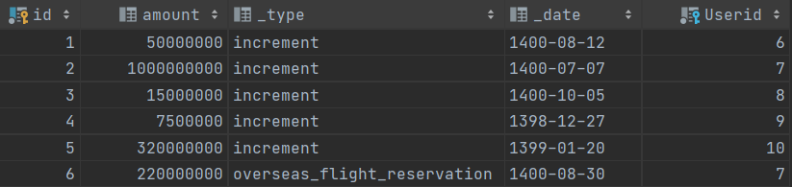

UPDATE Ticket  
SET _status = 0  
WHERE ticket_number = 1 and transportnumber = 3;

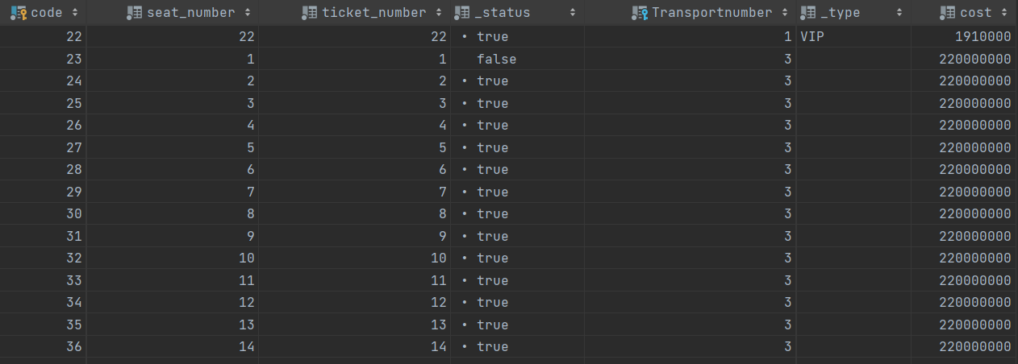

INSERT INTO transport_reservation (_date, number_of_adult, number_of_children, userid, Ticketcode)  
VALUES  
('1400/09/18', 1, 0, 9, 328);



UPDATE _user  
SET balance = balance - (SELECT cost FROM ticket WHERE code = 328)  
 WHERE id = 9;

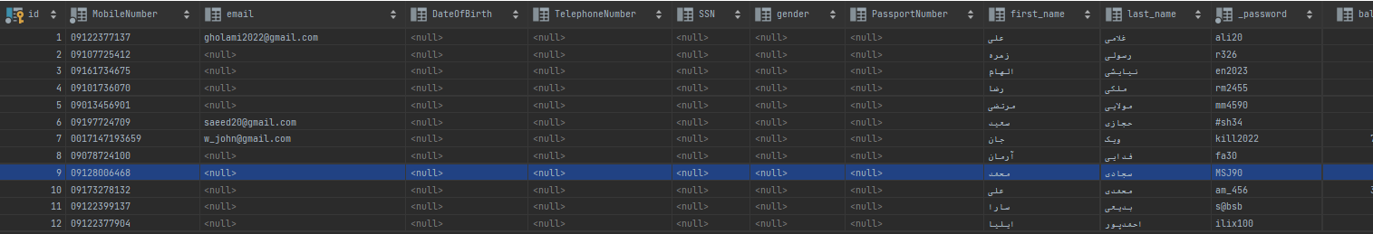

INSERT INTO transactions (amount, _type, _date, userid)  
VALUES  
((SELECT cost FROM ticket WHERE code = 328),'bus_reservation', '1400/09/18', 9);

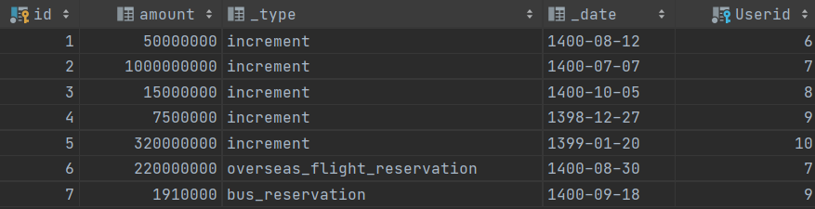

UPDATE Ticket  
SET _status = 0 where code = 328;

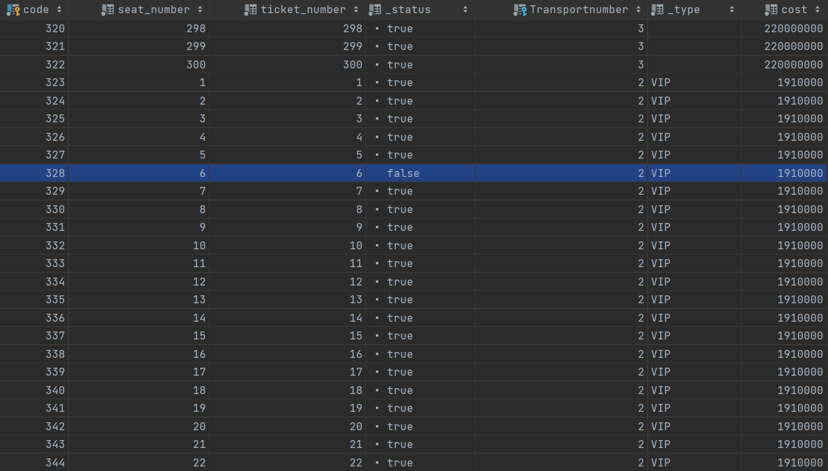

INSERT INTO transport_reservation (_date, number_of_adult, number_of_children, userid, Ticketcode)  
VALUES  
('1400/09/15', 1, 0, 2, 329);



INSERT INTO transactions (amount, _type, _date, userid)  
VALUES ((SELECT cost FROM ticket WHERE code = 329),'bus_reservation', '1400/09/15', 2);

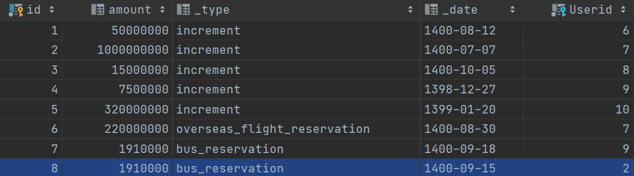

UPDATE Ticket  
SET _status = 0 WHERE code = 329

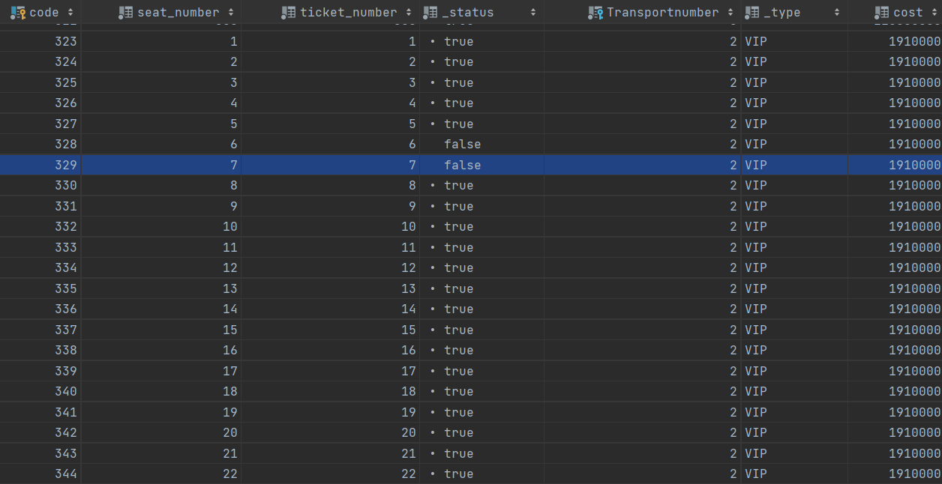

UPDATE Ticket  
SET _status = 1 WHERE seat_number = 7 and transportnumber = 2;

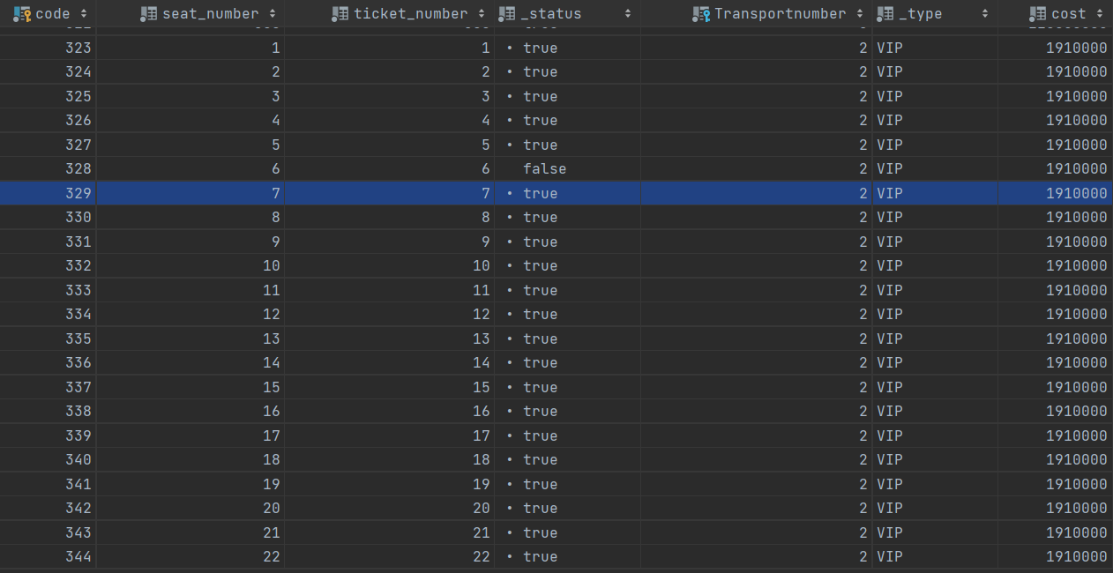

UPDATE Ticket  
SET _status = 0 WHERE seat_number = 10 and transportnumber = 2;

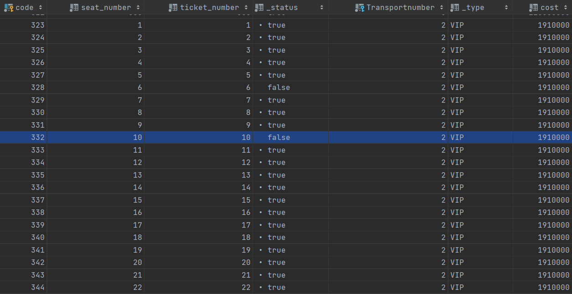

UPDATE Transport_Reservation  
SET Ticketcode = (SELECT code FROM Ticket WHERE seat_number = 10 and transportnumber = 2 )  
WHERE Userid = 2



INSERT INTO hotel (name, stars, cityid)  
VALUES  
(N'هتل اسپیناس', 5, 1);



BEGIN  
DECLARE @num int  
SET @num = 1;  
WHILE @num <= 10  
 BEGIN  
 INSERT INTO room (meal, Hotelid, _Type, available, cost_per_night, num_of_bedrooms, _number)  
 VALUES  
 ('BB', 1, 'VIP', 1, 12800000, 2, @num)  
 SET @num = @num + 1  
 END  
END

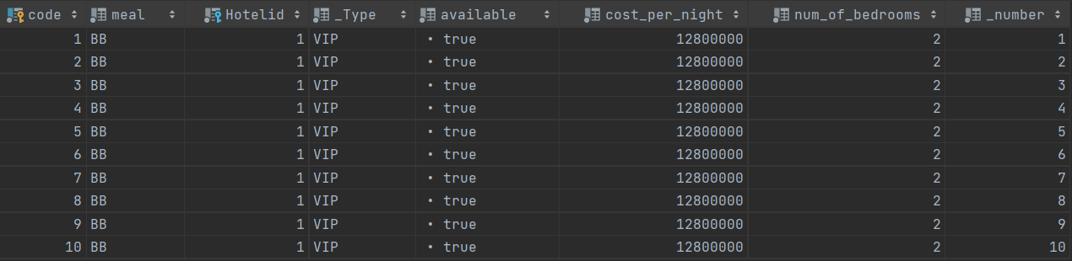

INSERT INTO hotel_reservation (checkin_date, checkout_date, _date, number_of_baby, number_of_adult, number_of_children, userid, Roomcode)  
VALUES  
('1400/09/20', '1400/09/21', '1400/09/01', 0, 1, 0, 7, 1);



UPDATE room  
SET available = 0  
WHERE _number = 1 and Hotelid = 1;

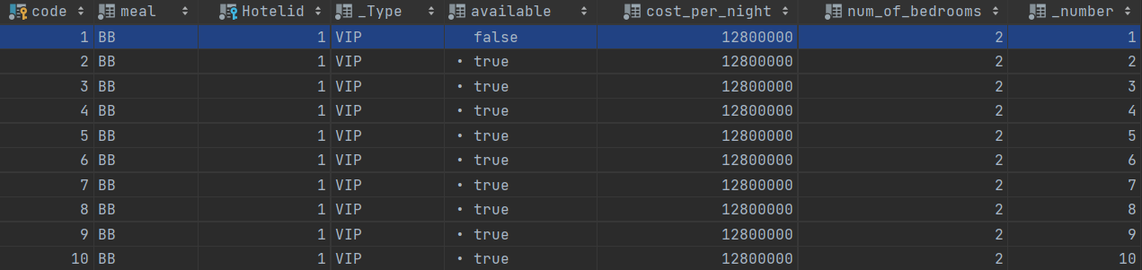

UPDATE _user  
SET balance = balance - (SELECT cost_per_night FROM room WHERE _number = 1 and hotelid = 1)  
WHERE id = 7;

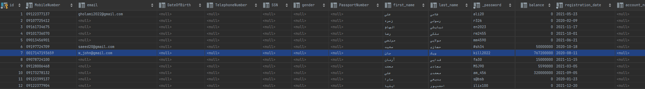

INSERT INTO transactions (amount, _type, _date, userid)  
VALUES ((SELECT cost_per_night FROM room WHERE _number = 1 and hotelid = 1),'hotel_reservation', '1400/09/01', 7);

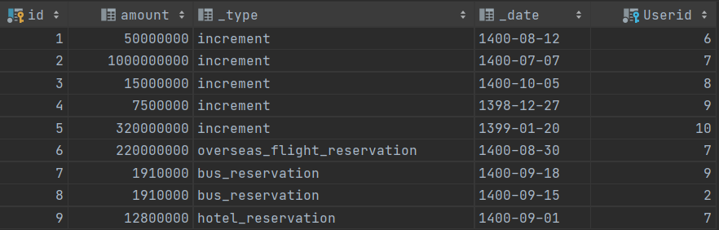

* **دستور Delete**

BEGIN  
DECLARE @Date DATE  
SET @Date = FORMAT(GETDATE(), 'yyyy/MM/dd', 'fa')  
DELETE from _user  
where DATEDIFF(day, @Date, registration_date) > 7  
and id not in (select Userid from Transactions)  
END



* **دستور Insert**

create table nzb_user(  
id int PRIMARY KEY,  
MobileNumber nvarchar(15) NOT NULL,  
email varchar(50) NULL,  
DateOfBirth date NULL,  
TelephoneNumber nvarchar(15) NULL,  
SSN nchar(10) NULL,  
gender char(1) NULL,  
PassportNumber nchar(9) NULL,  
first_name nvarchar(25) NULL,  
last_name nvarchar(25) NULL,  
_password nvarchar(50) NOT NULL,  
balance int DEFAULT 0 NULL,  
registration_date date NOT NULL,  
account_number nvarchar(25) NULL  
);

INSERT INTO nzb_user  
SELECT * FROM _user  
WHERE balance != 0;



* **دستور View**

CREATE VIEW nzb_user_v AS  
SELECT *  
FROM nzb_user



* **Stored Procedure**

**1**

CREATE PROCEDURE *purchasedTickets* @origin nvarchar(50), @destination nvarchar(50), @X nvarchar(50)  
AS  
BEGIN  
 IF @X = N'رفت و برگشت'  
 BEGIN  
 select count(*) as Two_Way_Count  
 from  
 (SELECT DISTINCT _user.*  
 from _user, Transport_Reservation  
 where _user.id = Transport_Reservation.Userid  
 and _user.id in ( select TR1.Userid  
 from Transport_Reservation TR1, Transport_Reservation TR2, Flight F1, Flight F2, Transport T1, Transport T2, Ticket TT1, Ticket TT2, Two_Way  
 where TR1.Ticketcode = TT1.code  
 and TR2.Ticketcode = TT2.code  
 and TT1.Transportnumber = T1._number  
 and TT2.Transportnumber = T2._number  
 and T1._number = F1.Transportnumber  
 and T2._number = F2.Transportnumber  
 and TR1._date = TR2._date  
 and T1.origin_city_id = T2.destination_city_id  
 and (Two_Way.DomesticFlightTransportnumber1 = F1.Transportnumber  
 or Two_Way.OverseasFlightTransportnumber1 = F1.Transportnumber  
 )  
 and (Two_Way.DomesticFlightTransportnumber2 = F2.Transportnumber  
 or Two_Way.OverseasFlightTransportnumber2 = F2.Transportnumber)  
 and T1.origin_city_id = (select City.id FROM City where City.name = @origin)  
 and T1.destination_city_id = (select City.id from City where City.name = @destination)  
 )) as [uTRu.*]  
 END  
 IF @X = N'یک طرفه'  
 BEGIN  
 select count(*) One_Way_Count  
 from  
 (SELECT DISTINCT _user.*  
 from _user, Transport_Reservation, Ticket  
 where Transport_Reservation.Userid = _user.id  
 and Transport_Reservation.Ticketcode = Ticket.code  
 and Ticket.Transportnumber in ( select Transport._number  
 from Transport_Reservation, Transport, Flight, One_Way, Ticket  
 where Transport._number = Flight.Transportnumber  
 and Transport_Reservation.Ticketcode = Ticket.code  
 and (One_Way.OverseasFlightTransportnumber = Flight.Transportnumber  
 or One_Way.DomesticFlightTransportnumber = Flight.Transportnumber)  
 and (Flight.Transportnumber = One_Way.DomesticFlightTransportnumber  
 or Flight.Transportnumber = One_Way.OverseasFlightTransportnumber)  
 and Transport.origin_city_id = (select City.id FROM City where City.name = @origin)  
 and Transport.destination_city_id = (select City.id from City where City.name = @destination)  
 )) as [uTRu.*2]  
 END  
 IF @X = N'چند مسیره'  
 BEGIN  
select count(*) Multi_Way_Count  
from  
 (SELECT DISTINCT _user.*  
 from _user, Transport_Reservation, Ticket, Flight, Transport, Multi_Way, MultiWay_Overseas  
 where Transport_Reservation.Userid = _user.id  
 and MultiWay_Overseas.OverseasFlightTransportnumber = Flight.Transportnumber  
 and Multi_Way.id = MultiWay_Overseas.MultiWayid  
 and Transport_Reservation.Ticketcode = Ticket.code  
 and Flight.Transportnumber = Ticket.Transportnumber  
 and Transport._number = Flight.Transportnumber  
 and _user.id not in (select TR1.Userid  
 from Transport_Reservation TR1, Transport_Reservation TR2, Flight F1, Flight F2, Transport T1, Transport T2, Ticket TT1, Ticket TT2, Two_Way  
 where TR1.Ticketcode = TT1.code  
 and TR2.Ticketcode = TT2.code  
 and TT1.Transportnumber = T1._number  
 and TT2.Transportnumber = T2._number  
 and T1._number = F1.Transportnumber  
 and T2._number = F2.Transportnumber  
 and TR1._date = TR2._date  
 and T1.origin_city_id = T2.destination_city_id  
 and (Two_Way.DomesticFlightTransportnumber1 = F1.Transportnumber  
 or Two_Way.OverseasFlightTransportnumber1 = F1.Transportnumber  
 )  
 and (Two_Way.DomesticFlightTransportnumber2 = F2.Transportnumber  
 or Two_Way.OverseasFlightTransportnumber2 = F2.Transportnumber))  
 and Ticket.Transportnumber not in (select Transport._number  
 from Transport_Reservation, Transport, Flight, One_Way, Ticket  
 where Transport._number = Flight.Transportnumber  
 and Transport_Reservation.Ticketcode = Ticket.code  
 and (One_Way.OverseasFlightTransportnumber = Flight.Transportnumber  
 or One_Way.DomesticFlightTransportnumber = Flight.Transportnumber)  
 and (Flight.Transportnumber = One_Way.DomesticFlightTransportnumber  
 or Flight.Transportnumber = One_Way.OverseasFlightTransportnumber))  
 and Transport.origin_city_id = (select City.id FROM City where City.name = @origin)  
 and Transport.destination_city_id = (select City.id from City where City.name = @destination)  
 ) as [uTRu.*3]  
 END  
END

EXEC *purchasedTickets* @origin = N'تهران', @destination = N'نجف', @X = N'رفت و برگشت';







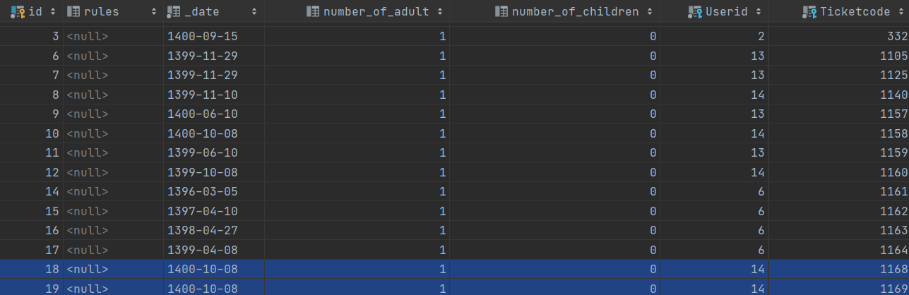

**2**

CREATE PROCEDURE *userWalletDetail* @A nchar(1)  
AS  
SELECT transactions._type  
FROM _user, transactions  
where _user.id = Transactions.Userid  
 and _user.last_name like '%'+ @A  
 and Transactions._date = (SELECT max(_date) from Transactions where _user.id = Transactions.Userid)

EXEC *userWalletDetail* @A = N'ی'

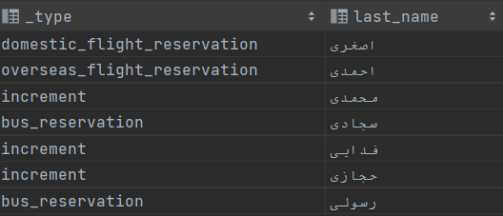 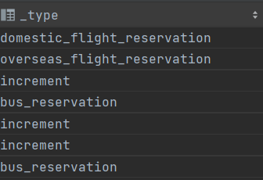

3

CREATE PROCEDURE *allDomesticFlights* @origin nvarchar(50), @destination nvarchar(50), @date nvarchar(50)  
AS  
SELECT distinct company.name as flight_company_name  
FROM transport, Company, flight, domestic  
where Transport._number = Flight.Transportnumber  
and Domestic.FlightTransportnumber = Flight.Transportnumber  
and Transport.Companyid = Company.id  
and Transport.origin_city_id = (select City.id from City where City.name = @origin)  
and Transport.destination_city_id = (select City.id from City where City.name = @destination)  
and Transport._date = @date

EXEC *allDomesticFlights* @origin = N'تهران', @destination = N'کیش', @date = '1400/12/11';

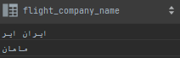

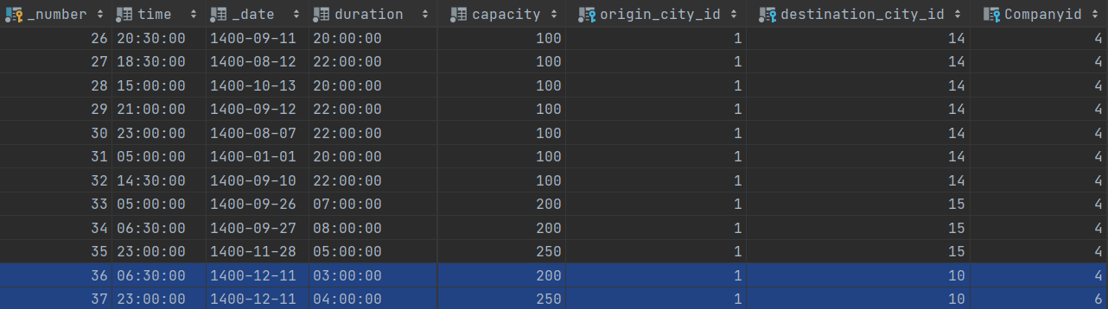

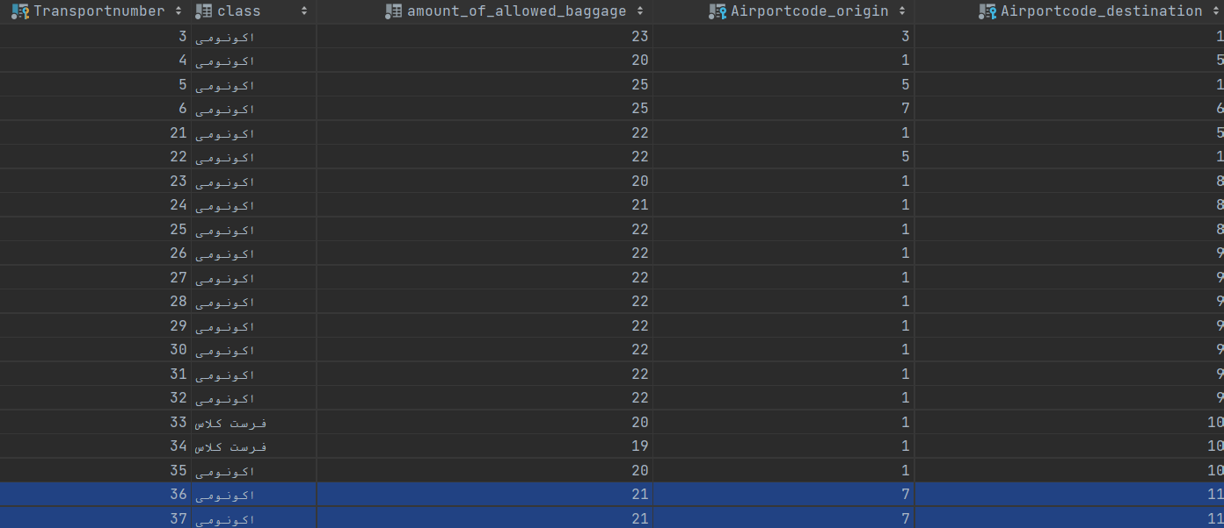

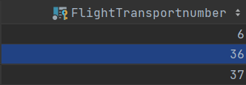

4

CREATE PROCEDURE *internationalTickets* @origin nvarchar(50), @destination nvarchar(50), @c int  
AS  
select avg(len(last_name)) as last_name_average  
from _user  
where _user.id in  
(select _user.id  
from _user, Transport_Reservation, Transport, Flight, Overseas, Ticket  
where _user.id = Transport_Reservation.Userid  
and Transport_Reservation.Ticketcode = Ticket.code  
and Ticket.Transportnumber = Transport._number  
and Transport._number = Flight.Transportnumber  
and Flight.Transportnumber = Overseas.FlightTransportnumber  
and Transport.origin_city_id = (select City.id from City where City.name = @origin)  
and Transport.destination_city_id = (select City.id from City where City.name = @destination)  
group by _user.id  
having count(*) > @c)



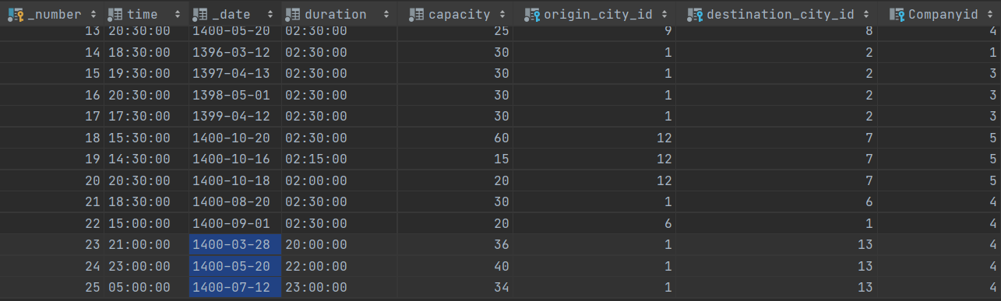

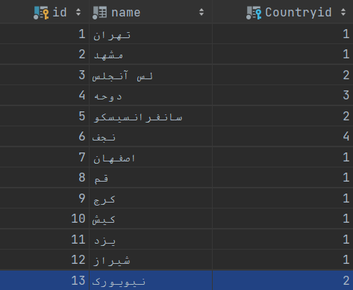



**5**

CREATE PROCEDURE *terminalBuses* @terminal nvarchar(50), @origin nvarchar(50), @destination nvarchar(50), @company_name nvarchar(50), @date date  
AS  
SELECT DISTINCT Transport.time, Transport._date, Transport.capacity, c1.name as origin, c2.name as destination ,Bus_Terminal.name,Company.name  
FROM _user, transport_reservation, transport, bus, company,bus_terminal, city c1, city c2  
where _user.id = transport_reservation.userid  
 and transport._number = bus.transportnumber  
 and bus.Bus_Origin_Terminalid = bus_terminal.id  
 and Transport.companyid = company.id  
 and transport.origin_city_id = c1.id  
 and transport.destination_city_id = c2.id  
 and bus_terminal.name = @terminal  
 and c1.name = @origin  
 and c2.name = @destination  
 and company.name = @company_name  
 and transport._date = @date

EXEC *terminalBuses* @terminal = N'غرب' , @origin = N'تهران', @destination = N'اصفهان', @company_name = N'رویال سفر', @date = '1400/10/17';



6

CREATE PROCEDURE *hotelOrBusUsers* @A int, @city nvarchar(50)  
AS  
SELECT avg(balance) as AverageOfBalance  
from _user  
where _user.id in (SELECT _user.id  
 FROM _user, transport_reservation, transport, bus, hotel_reservation, Hotel, Room, Ticket  
 where _user.id = transport_reservation.userid  
 and Transport_Reservation.Ticketcode = Ticket.code  
 and Ticket.Transportnumber = Transport._number  
 and transport._number = bus.transportnumber  
 and Hotel_Reservation.Userid = _user.id  
 and Hotel_Reservation.Roomcode = Room.code  
 and Room.Hotelid = Hotel.id  
 and transport.origin_city_id = (select City.id from City where City.name = @city)  
 group by _user.id  
 having count(*) >= @A)

EXEC *hotelOrBusUsers* @A = 2, @city = N'تهران'

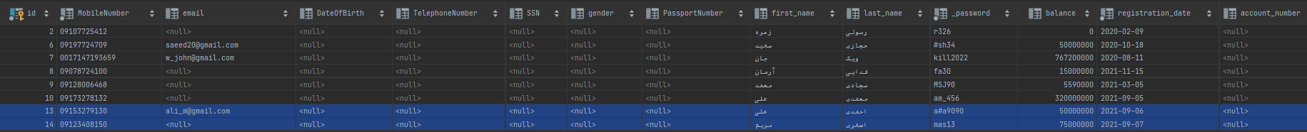

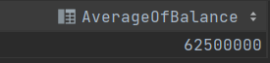

7

CREATE PROCEDURE *internationalFlight* @X int , @origin nvarchar(50), @destination nvarchar(50), @N int  
AS  
BEGIN  
DECLARE @Date DATE  
SET @Date = FORMAT(GETDATE(), 'yyyy/MM/dd', 'fa')  
select top (@X) *  
from Transport, Flight, Overseas, Ticket  
where Transport._number = Flight.Transportnumber  
and Flight.Transportnumber = Ticket.Transportnumber  
and Overseas.FlightTransportnumber = Flight.Transportnumber  
and Transport.origin_city_id = (select City.id from City where City.name = @origin)  
and Transport.destination_city_id = (select City.id from City where City.name = @destination )  
and DATEDIFF(month, @Date, Transport._date) between -@N and 0  
order by Ticket.cost  
END

EXEC *internationalFlight* @X = 5, @origin = N'تهران', @destination = N'تورنتو', @N= 3;



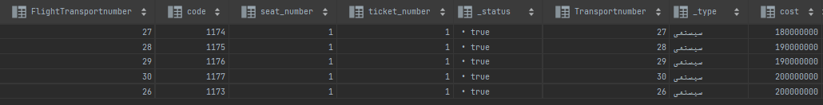

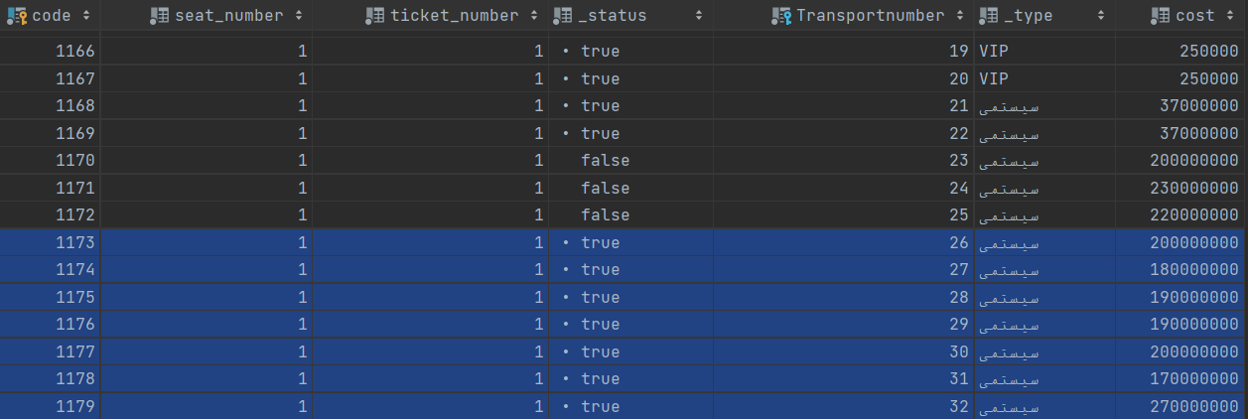

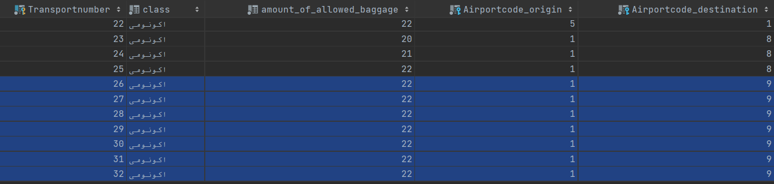

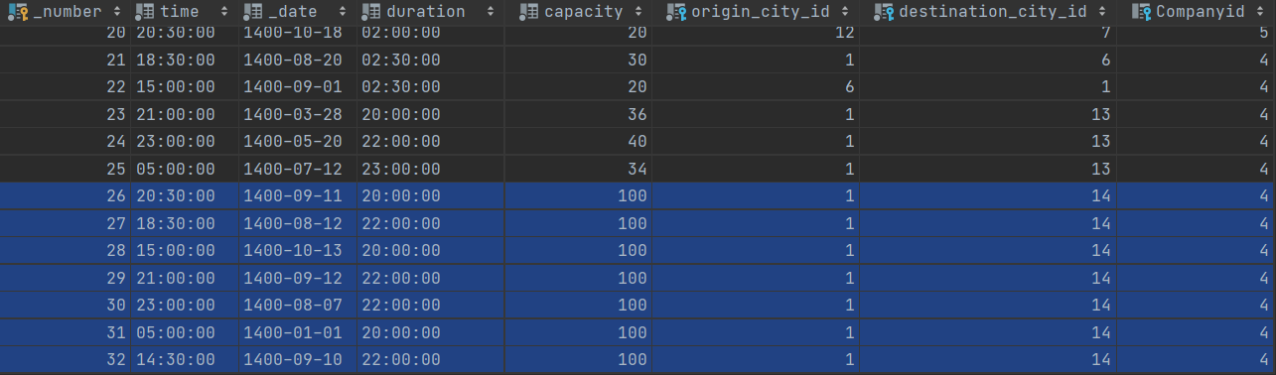

8

CREATE PROCEDURE *allInternationalTickets* @class nvarchar(50), @origin nvarchar(50), @destination nvarchar(50), @date1 date, @date2 date  
AS  
SELECT *  
FROM transport, flight, overseas, ticket  
where transport._number = flight.transportnumber  
 and Flight.Transportnumber = Overseas.FlightTransportnumber  
 and Ticket.Transportnumber = Transport._number  
 and transport.origin_city_id = (select City.id from City where City.name = @origin)  
 and transport.destination_city_id = (select City.id from City where City.name = @destination)  
 and flight.class = @class  
 and transport._date between @date1 and @date2

EXEC *allInternationalTickets* @class = N'فرست کلاس', @origin = N'تهران', @destination = N'فرانکفورت', @date1 = '1400/09/25', @date2 = '1400/09/30';





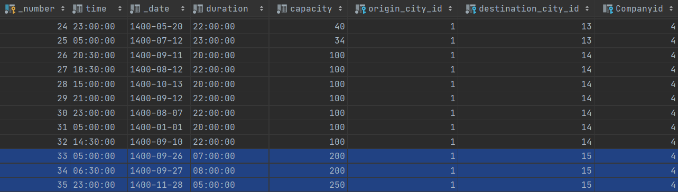

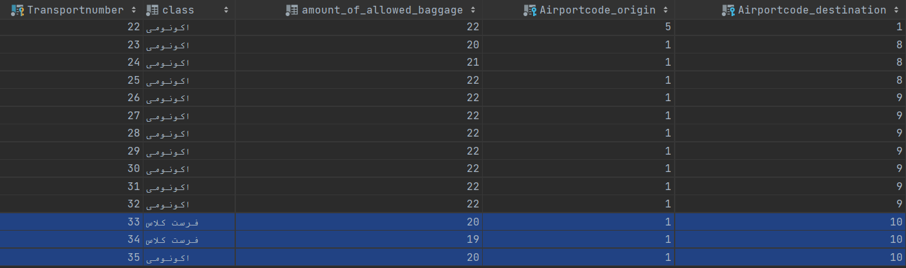

9

CREATE PROCEDURE *joinedUsers* @date1 date, @date2 date, @C int  
AS  
SELECT _user.*  
FROM _user, transport_reservation, transport, Ticket  
where _user.id = transport_reservation.userid  
 and Transport_Reservation.Ticketcode = Ticket.code  
 and Transport._number = Ticket.Transportnumber  
 and ((registration_date between @date2 and @date1)  
 or (select count(*)  
 from Transport_Reservation  
 where Transport_Reservation.Userid = _user.id  
 ) < @C)

EXEC *joinedUsers* @date1 = '1400/09/25', @date2 = '1400/10/13', @C = 2;



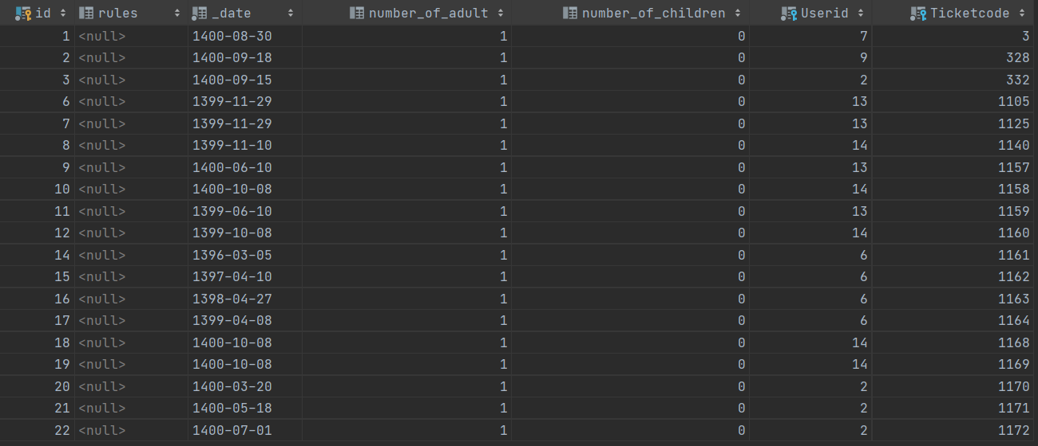

10

CREATE PROCEDURE *myTrips* @first_name nvarchar(50), @last_name nvarchar(50)  
AS  
SELECT transport_reservation._date, Ticket.ticket_number, Ticket.seat_number, Ticket.cost, c1.name as origin, c2.name as destination  
FROM _user, transport_reservation, Ticket, Transport, City c1, City c2  
where _user.id = transport_reservation.userid  
 and Transport_Reservation.Ticketcode = Ticket.code  
 and Ticket.Transportnumber = Transport._number  
 and _user.first_name = @first_name  
 and _user.last_name = @last_name  
 and Transport.origin_city_id = c1.id  
 and Transport.destination_city_id = c2.id

EXEC *myTrips* @first_name = N'سجاد', @last_name = N'محمدی';

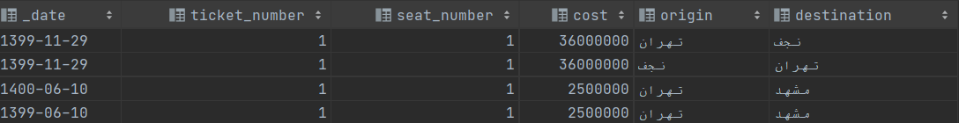

11

drop procedure *chargedUsers*CREATE PROCEDURE *chargedUsers* @X int, @Y int  
AS  
select count(*) as number_of_user  
from _user  
where  
_user.id in (SELECT _user.id  
 FROM _user, transactions  
 where _user.id = Transactions.Userid  
 and Transactions._type = 'increment'  
 group by _user.id  
 having count(*) >= @X)  
and _user.id in (SELECT _user.id  
 FROM _user, transactions  
 where _user.id = Transactions.Userid  
 and Transactions._type != 'increment'  
 group by _user.id  
 having count(*) <= @Y)

EXEC *chargedUsers* @X = 7, @Y = 15;



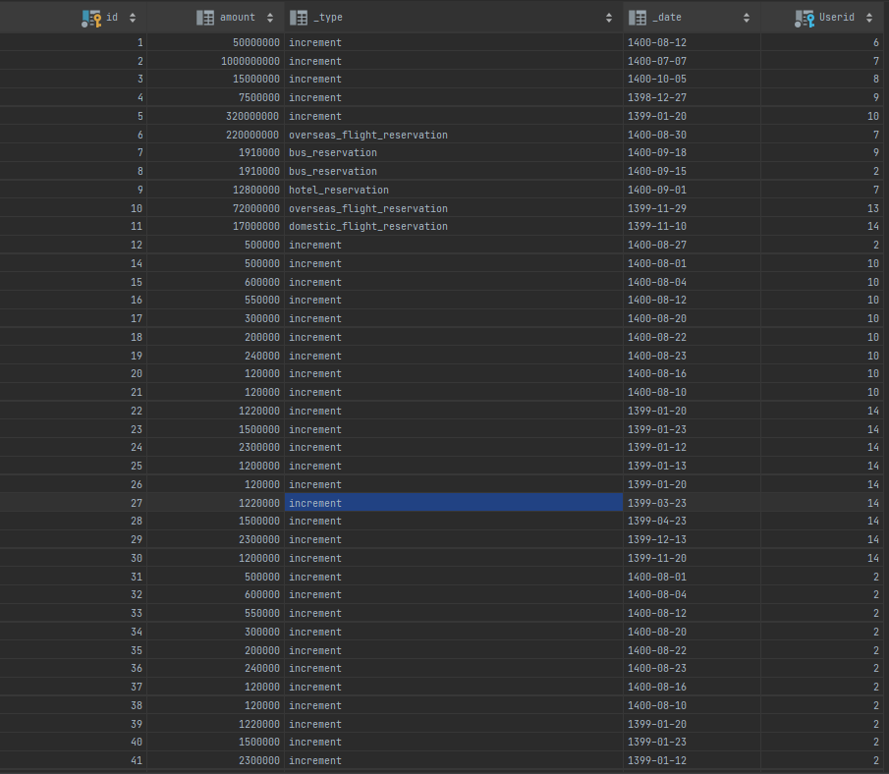

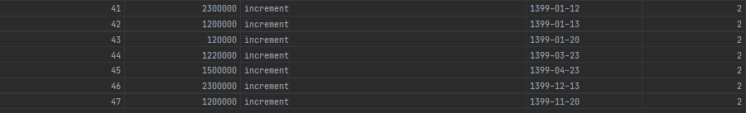

12

CREATE PROCEDURE *allBusTickets_1* @origin nvarchar(50), @destination nvarchar(50)  
AS  
SELECT DISTINCT company.name as CompanyName  
FROM company, Transport, Bus  
where Transport.Companyid = Company.id  
and Transport._number = Bus.Transportnumber  
and Company.id not in (SELECT Company.id  
 FROM Company, Transport, Bus  
 where Transport.Companyid = Company.id  
 and Transport._number = Bus.Transportnumber  
 and Transport.origin_city_id = (select City.id from City WHERE City.name = @origin)  
 and Transport.destination_city_id = (select City.id from City WHERE City.name = @destination)  
 )

EXEC *allBusTickets_1* @origin = N'کرج', @destination = N'قم';

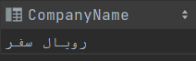

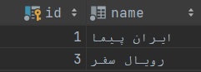

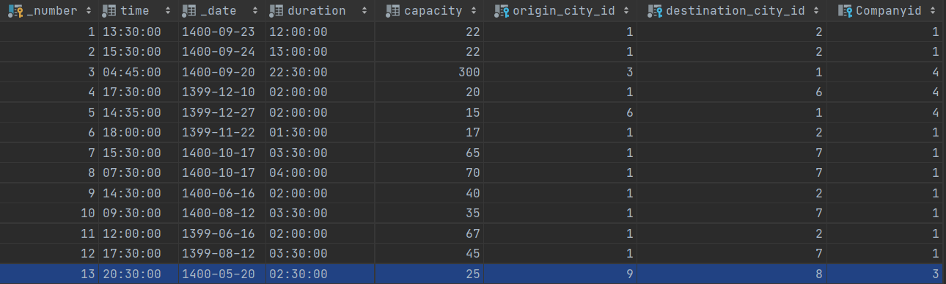

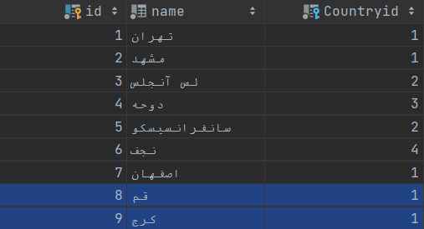

13

drop procedure *allBusTickets_2*CREATE PROCEDURE *allBusTickets_2* @origin nvarchar(50), @destination nvarchar(50), @company nvarchar(50), @cost int  
AS  
BEGIN  
 DECLARE @Date DATE  
 SET @Date = FORMAT(GETDATE(), 'yyyy/MM/dd', 'fa')  
 select Transport.time, Transport._date, Transport.capacity, Ticket.*, Company.name  
 from Transport, Bus, Ticket, Company  
 where Bus.Transportnumber = Transport._number  
 and Transport._number = Ticket.Transportnumber  
 and Company.id = Transport.Companyid  
 and (Transport._date in  
 (select MIN(Transport._date)  
 from Transport, Bus, Ticket, Company  
 where Transport._number = Bus.Transportnumber  
 and Ticket.Transportnumber = Transport._number  
 and Company.id = Transport.Companyid  
 and Transport._date >= @Date  
 group by Transport.Companyid)  
 or Transport.capacity in  
 (select max(Transport.capacity)  
 from Transport, Bus, Ticket, Company  
 where Transport._number = Bus.Transportnumber  
 and Ticket.Transportnumber = Transport._number  
 and Company.id = Transport.Companyid  
 group by Transport.Companyid)  
 and Ticket.cost < @cost  
 and Company.name = @company  
 and Transport.origin_city_id = (select City.id from City where City.name = @origin)  
 and Transport.destination_city_id = (select City.id from City where City.name = @destination))  
END

EXEC *allBusTickets_2* @origin = N'شیراز', @destination = N'اصفهان', @comPany = N'سیر و سفر', @cost = 300000;



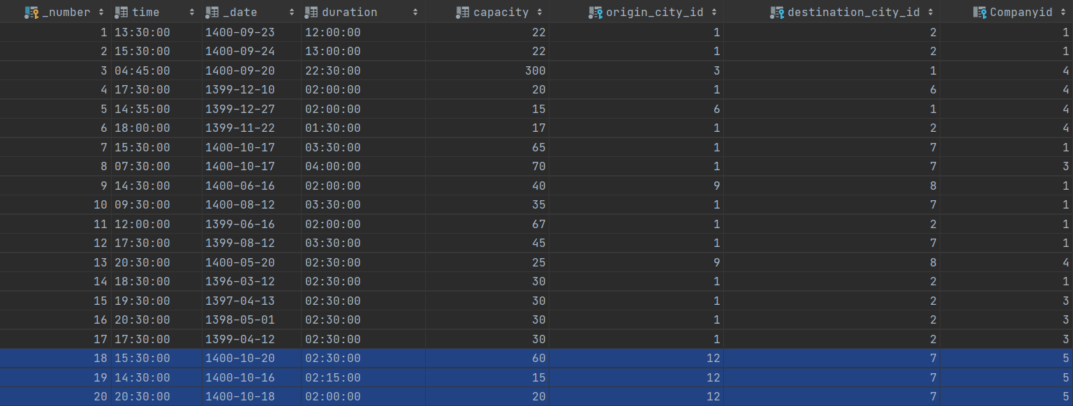

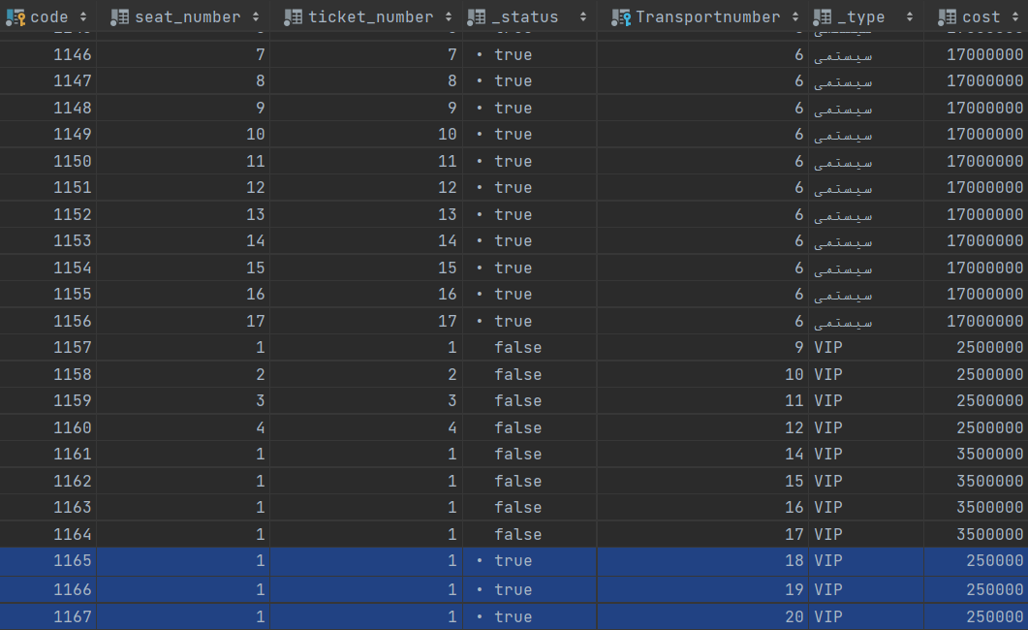

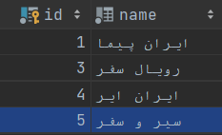

14

CREATE PROCEDURE *twoTrips* @origin nvarchar(50), @destination1 nvarchar(50), @destination2 nvarchar(50)  
AS  
SELECT DISTINCT _user.first_name, _user.last_name  
FROM _user, transport_reservation tr1, transport t1, transport_reservation tr2, transport t2, Domestic, bus, Ticket tick1, Ticket tick2, Overseas, Flight f1, Flight f2  
where _user.id = tr1.userid  
 and _user.id = tr2.userid  
 and tr1.Ticketcode = tick1.code  
 and tr2.Ticketcode = tick2.code  
 and tick1.Transportnumber = t1._number  
 and tick2.Transportnumber = t2._number  
 and ((f1.Transportnumber = tick1.Transportnumber  
 and f1.Transportnumber = Domestic.FlightTransportnumber)  
 or (Bus.Transportnumber = tick1.Transportnumber))  
 and f2.Transportnumber = tick2.Transportnumber  
 and f2.Transportnumber = Overseas.FlightTransportnumber  
 and t1._date < t2._date  
 and t1.origin_city_id = (select City.id from City where City.name = @origin)  
 and t1.destination_city_id = (select City.id from City where City.name = @destination1)  
and t2.origin_city_id = (select City.id from City where City.name = @destination1)  
and t2.destination_city_id = (select City.id from City where City.name = @destination2)

EXEC *twoTrips* @origin = N'تهران', @destination1 = N'کیش', @destination2 = N'دبی'



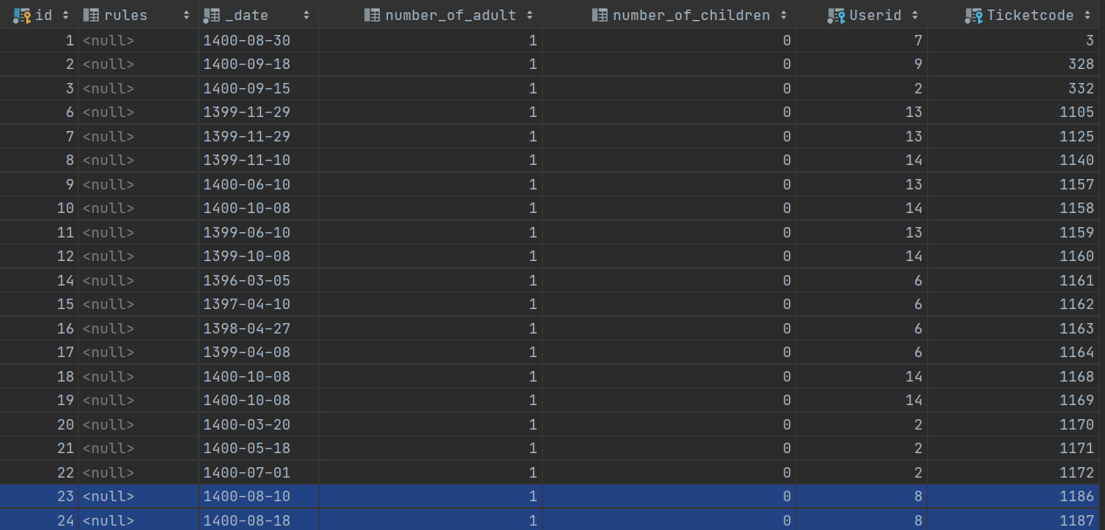

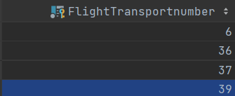

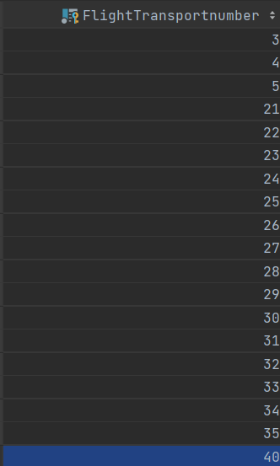

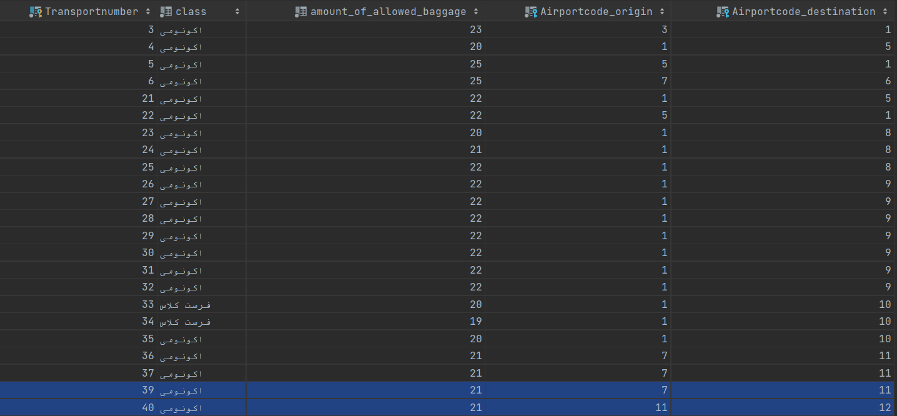

15

CREATE PROCEDURE *lastChange* @first_name nvarchar(25), @last_name nvarchar(25)  
AS  
SELECT _type, _date  
FROM Transactions  
WHERE _date = (SELECT max(Transactions._date)  
 FROM _user, transactions  
 where _user.id = Transactions.userid  
 and _user.first_name = @first_name  
 and _user.last_name = @last_name)

EXEC *lastChange* @first_name = N'زهره', @last_name = N'رسولی';



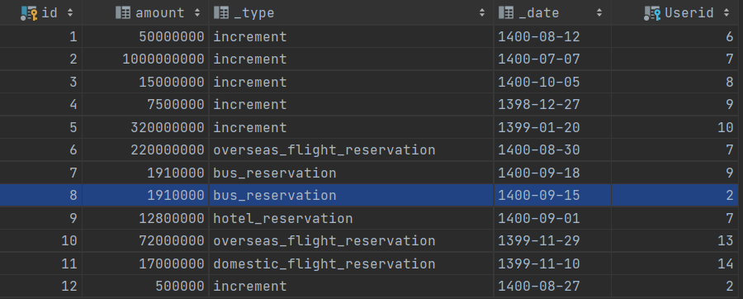

16

CREATE PROCEDURE *reserveHotel_1* @N int, @city nvarchar(50), @date1 date, @date2 date, @M int, @origin nvarchar(50), @date3 date, @date4 date  
AS  
SELECT *  
FROM _user  
where _user.id in (select _user.id  
 from _user ,hotel_reservation, Room, Hotel  
 where _user.id = hotel_reservation.userid  
 and hotel_reservation.Roomcode = Room.code  
 and Room.Hotelid = Hotel.id  
 and Hotel.Cityid = (select City.id from City where City.name = @city)  
 and hotel_reservation._date between @date1 and @date2  
 group by _user.id  
 having count(*) = @N  
 )  
 and _user.id in  
 (select _user.id  
 from _user, transport_reservation, transport , Bus, Ticket  
 where _user.id = transport_reservation.userid  
 and transport_reservation.Ticketcode = Ticket.code  
 and Ticket.Transportnumber = Transport._number  
 and Bus.Transportnumber = Transport._number  
 and Transport.origin_city_id = (select City.id from City where City.name = @origin)  
 and transport_reservation._date between @date3 and @date4  
 group by _user.id  
 having count(*) = @M  
 )

EXEC *reserveHotel_1* @N = 3, @city = N'کیش', @date1 = '1398/10/15', @date2 = '1400/10/15', @M = 4, @origin = N'تهران', @date3 = '1396/01/25', @date4 = '1399/05/11';



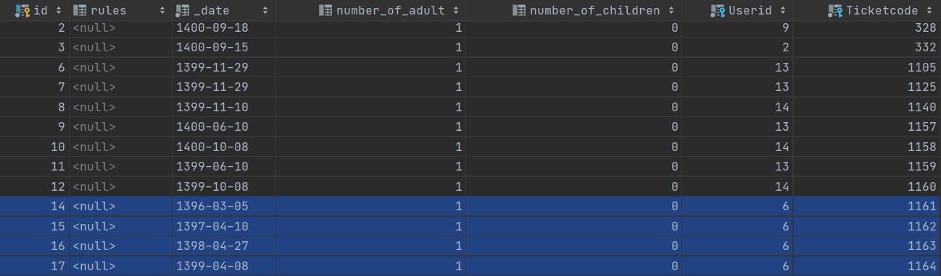

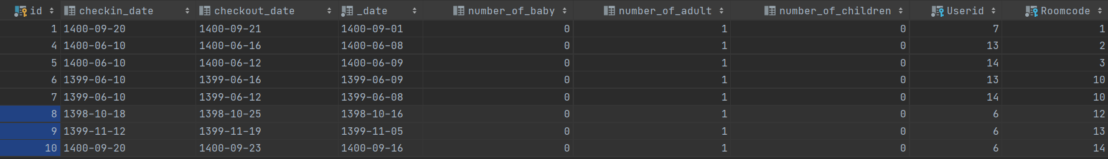

17

CREATE PROCEDURE *reserveHotel_2* @date1 date, @date2 date, @city nvarchar(50)  
AS  
select * from _user where _user.id in  
(select _user.id  
from _user, Hotel_Reservation, Hotel, Room  
where _user.id = Hotel_Reservation.Userid  
and hotel_reservation.Roomcode = Room.code  
and Room.Hotelid = Hotel.id  
and Hotel.Cityid = (select City.id from City where City.name = @city)  
and Hotel_Reservation._date between @date1 and @date2  
and Hotel.stars < 3  
group by _user.id  
having count(distinct Hotelid) = (select distinct count(*)  
 from Hotel  
 where Hotel.Cityid = (select City.id from City where City.name = N'یزد')  
 and Hotel.stars < 3))

EXEC *reserveHotel_2* @date1 = '1400/05/20', @date2 = '1400/09/20', @city = N'یزد';



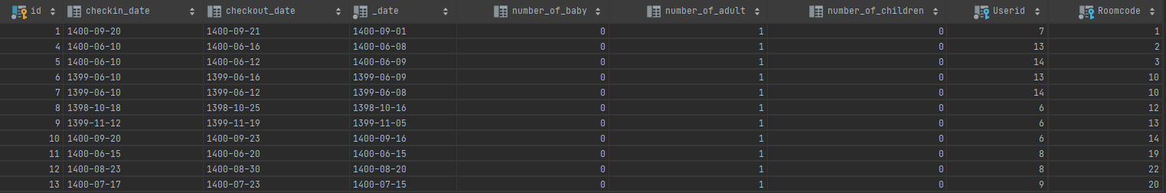

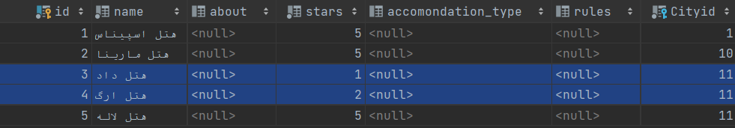

18

CREATE PROCEDURE *reserveHotel_3* @city nvarchar(50), @destination nvarchar(50)  
AS  
select _user.last_name  
from _user  
where _user.id not in (select _user.id  
from _user, Transport, Transport_Reservation, Ticket  
 where _user.id = Transport_Reservation.Userid  
 and Transport_Reservation.Ticketcode = Ticket.code  
 and Ticket.Transportnumber = Transport._number  
 and Transport.origin_city_id = (select city.id from city where city.name = @destination))  
or _user.id not in (select _user.id  
 from _user,Hotel_Reservation, Hotel, Room  
 where _user.id = Hotel_Reservation.Userid  
 and Hotel_Reservation.Roomcode = Room.code  
 and Room.Hotelid = Hotel.id  
 and Hotel.Cityid = (select city.id from city where city.name != @city))  
order by _user.last_name

EXEC *reserveHotel_3* @city = N'مشهد', @destination = N'بندرعباس';

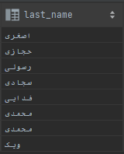

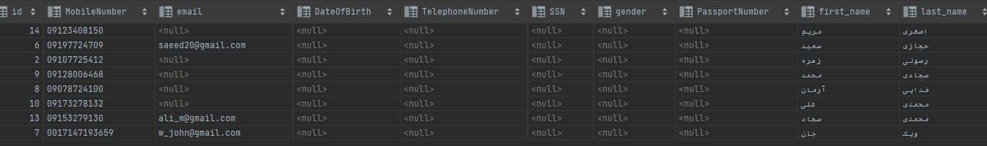

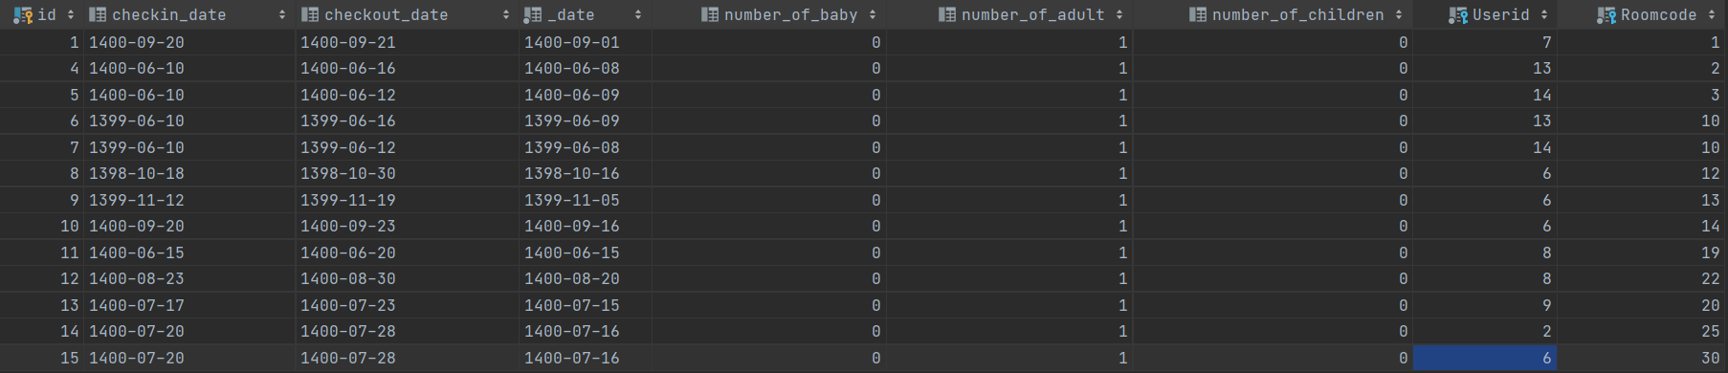

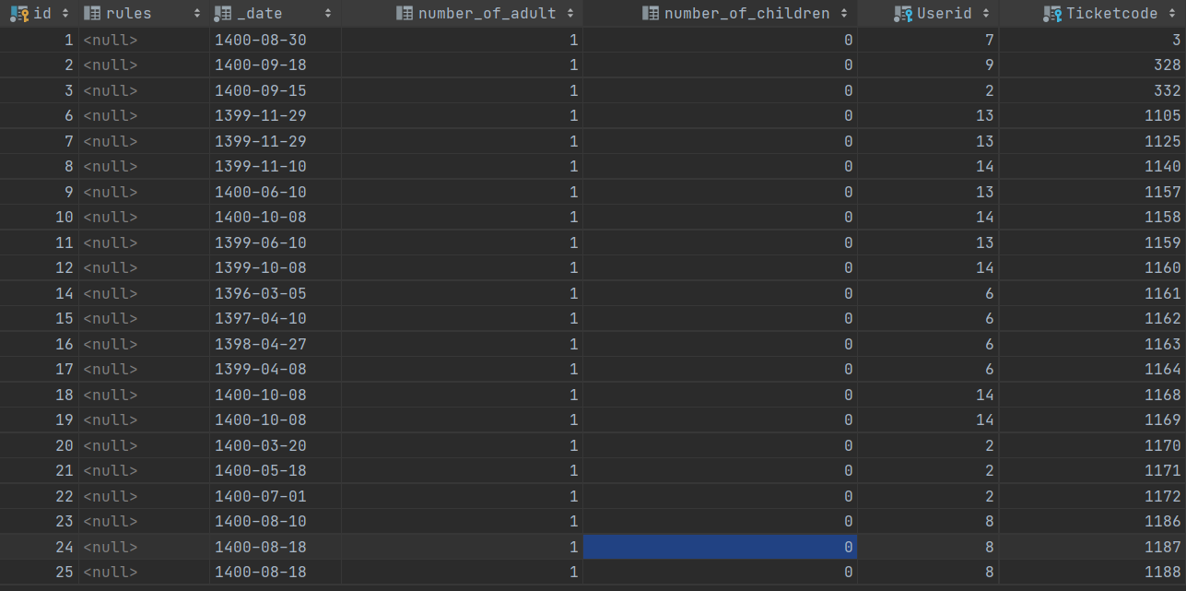

19

CREATE PROCEDURE *reserveHotel_4* @city nvarchar(50), @C int  
AS  
SELECT *  
FROM _user  
where _user.id in (select Hotel_Reservation.userid  
 from hotel_reservation , hotel , Room  
 where Hotel_Reservation.Roomcode = Room.code  
 and Room.Hotelid = Hotel.id  
 and DATEDIFF(day, Hotel_Reservation.checkin_date, Hotel_Reservation.checkout_date) > @C  
 and Hotel.Cityid = (select City.id from City where City.name = @city)  
)

EXEC *reserveHotel_4* @city = N'کیش', @C = 7;



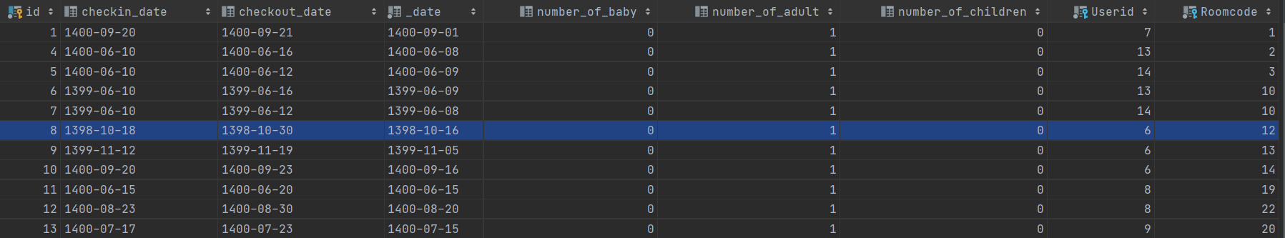

20

CREATE PROCEDURE *reserveHotel_5* @A int  
AS  
SELECT *  
FROM Hotel  
WHERE Hotel.id in  
(SELECT Hotel.id  
FROM Hotel, Hotel_Reservation, Room  
WHERE Hotel.id = Room.Hotelid  
 and Hotel_Reservation.Roomcode = Room.code  
 group by Hotel.id  
 having count(*) =  
(SELECT MAX (mycount)  
FROM (SELECT count(*) mycount  
FROM hotel_reservation,Room, Hotel  
where Hotel_Reservation.Roomcode = Room.code  
and Room.Hotelid = Hotel.id  
and Hotel.stars > @A  
group by Hotelid) as mH))

EXEC *reserveHotel_5* @A = 2;



